**Leave Management Workflow**

**LMS Home Page to get start Please use login:**

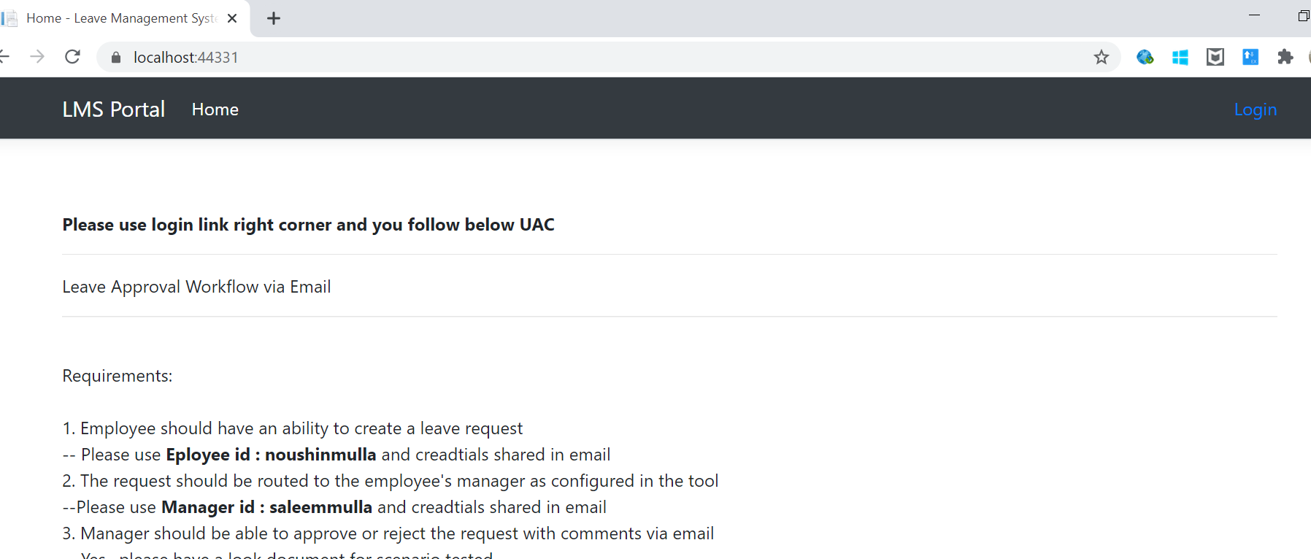

**Step1: Login As Employee using “noushinmulla” user**

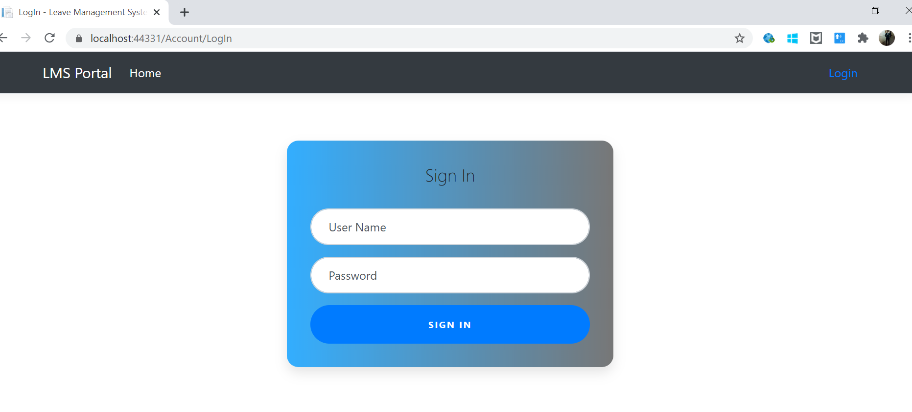

**Step 2: Employee home page** 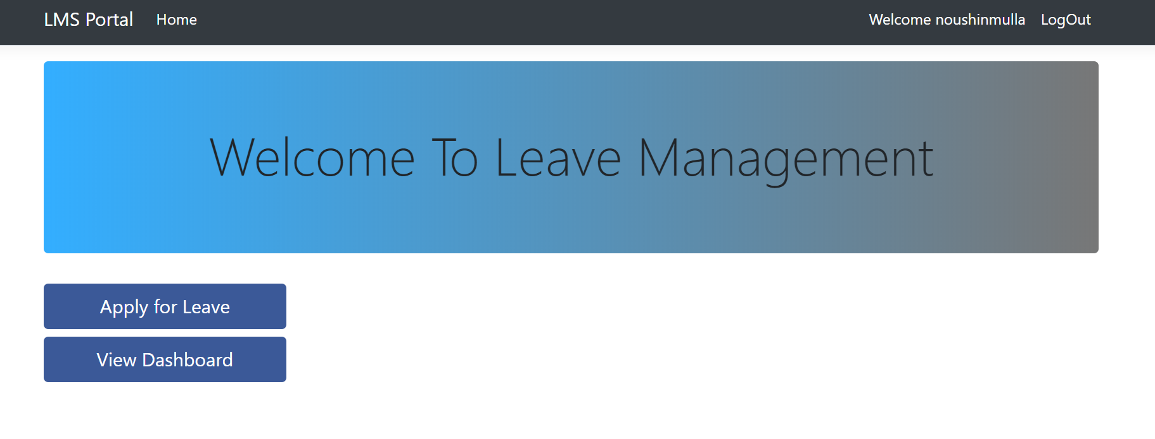

**Step 3: click apply for leave and do entry as shown below**

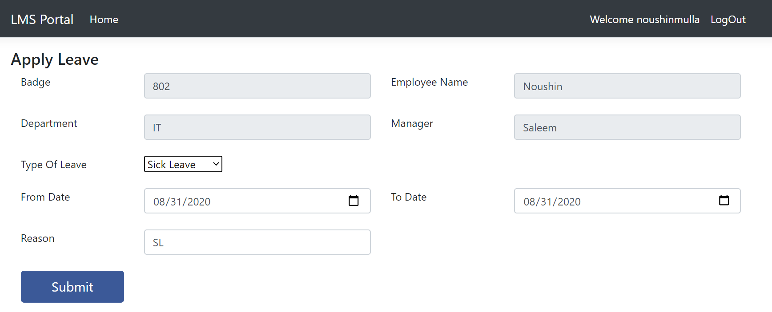

**Step 4: Upon successfully applying leave you will see below screen and email will also go to Manager**

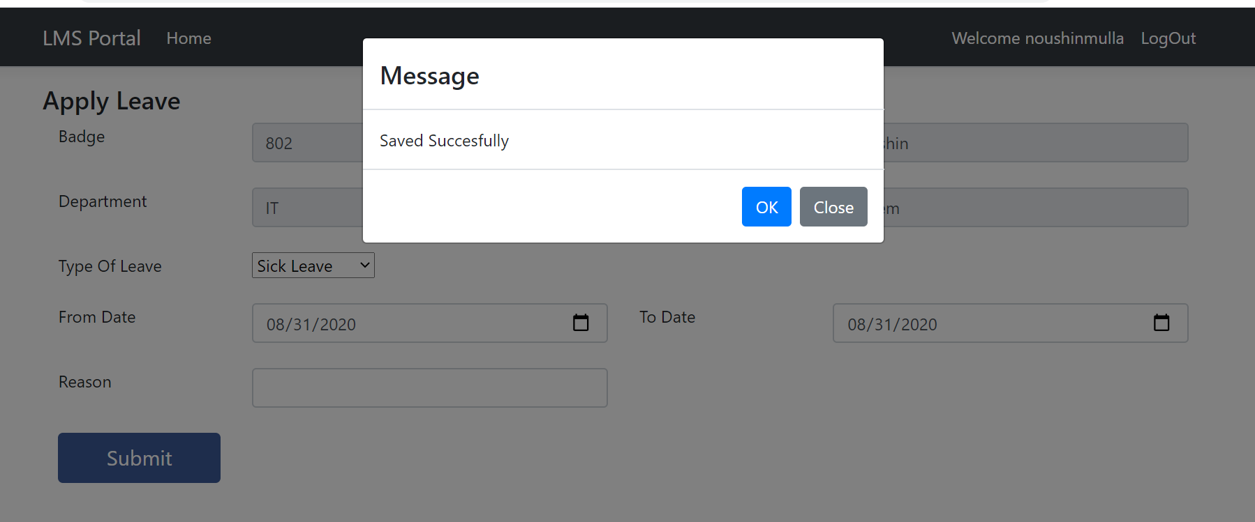

**Step5 : Email format sent to Manager:**

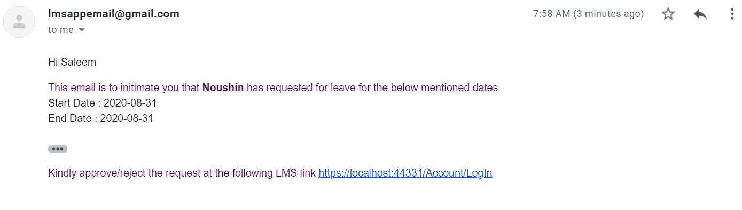

**Step 6: Click view dash board to see the all applied leasve and status.**

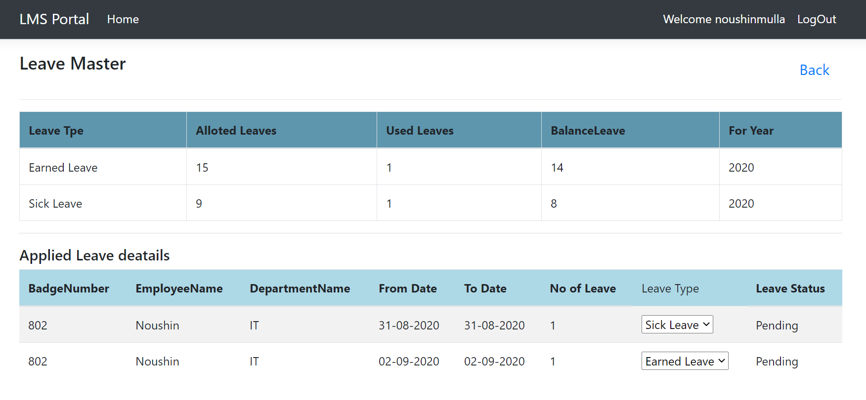

**Login as Manager using “saleemmulla” user**

**Step 7: Manager can able approve and Reject**

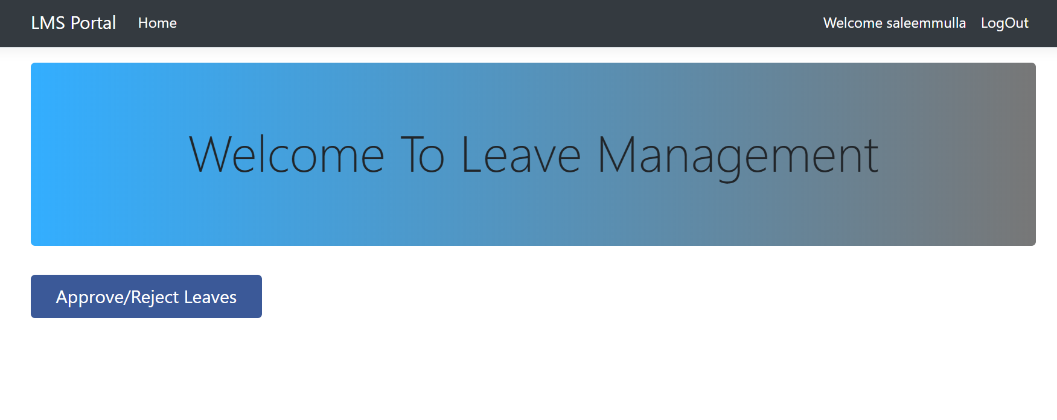

**Step 8: Approve/ Reject leave show all of his subordinate who raised leave.**

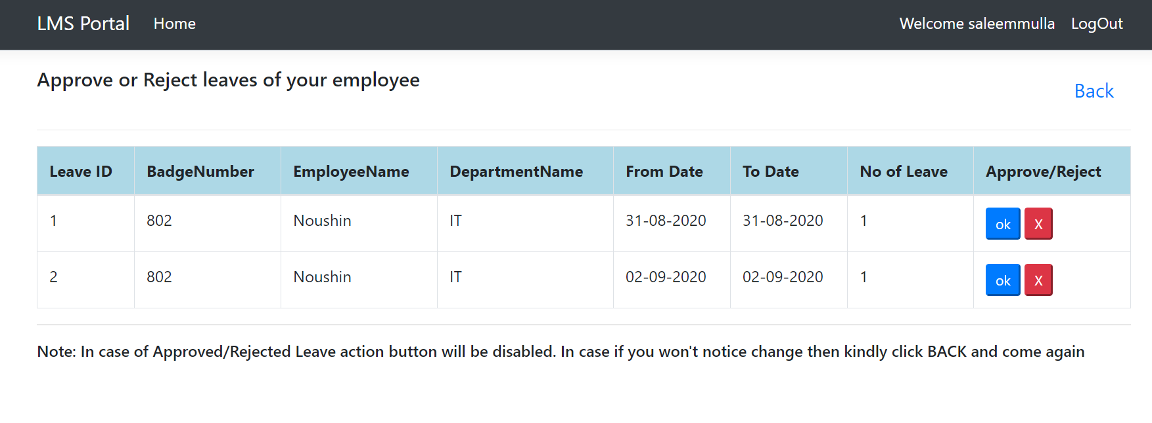

**Step 9: No as Manager I will Approve first leave : See the orde the leave approve moved to down in list and its action buttons are disable.**

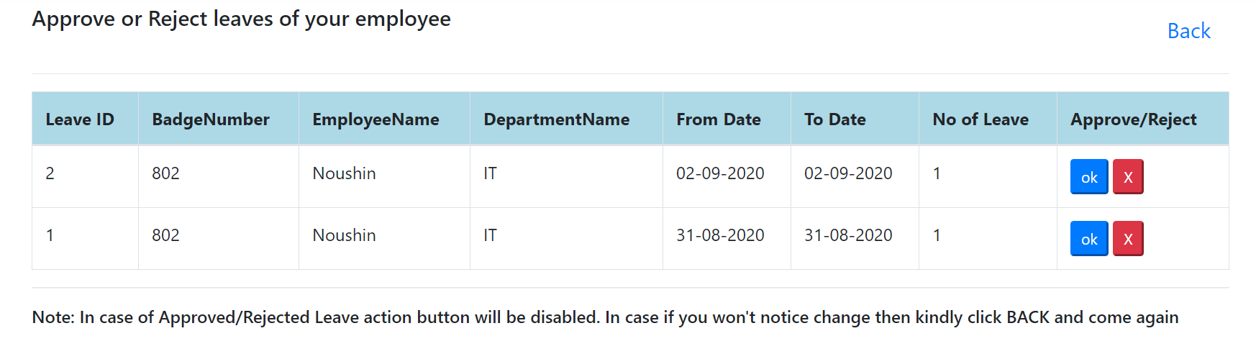

**Employee is received email about his approved leave status**.

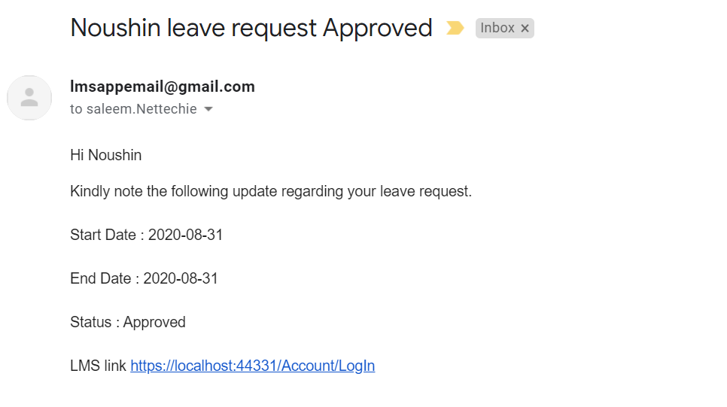

**Step 10: Now I will Reject second leave by this now took action on both item. Now leave list sorted in ascending order**.

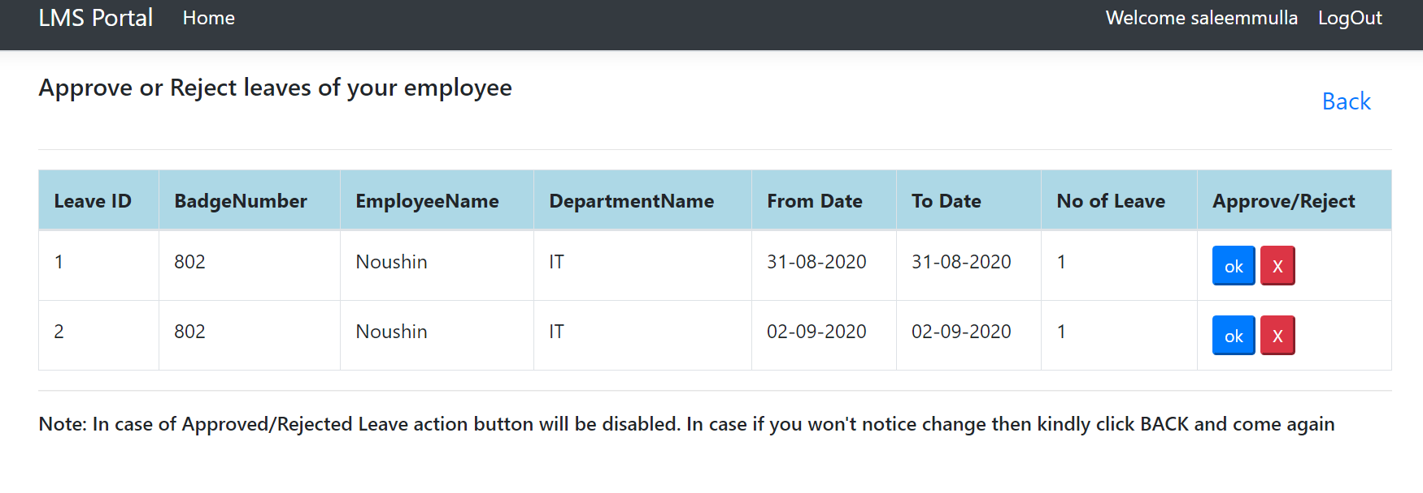

**Employee is received email about his Rejected leave status.**

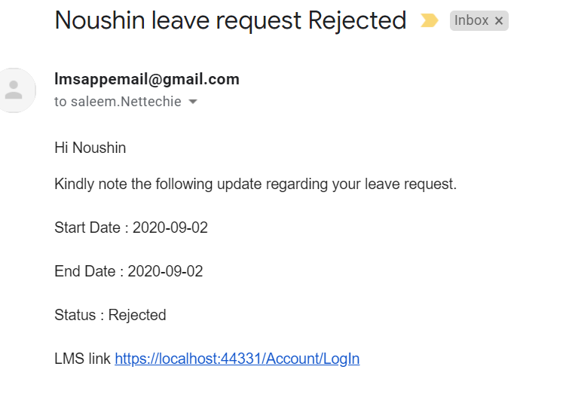

Now if we look view dashboard of Employee. Which gives you clear reconcile report to HR and employee.

